**[19] Design Turing Machine For Addition W = AA + AAAA**

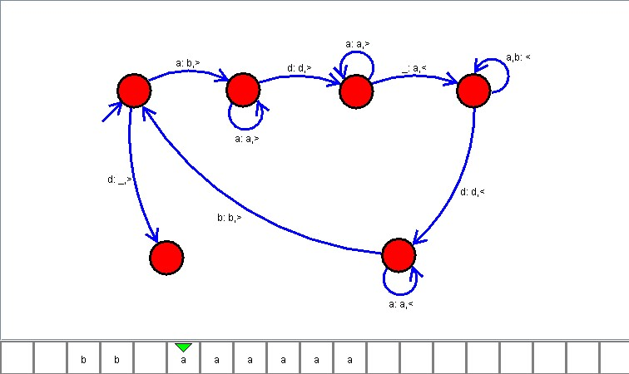

**Result**

The TM is designed to perform the addition with given strings as input using AutoSim tool